Lesser omentum

Features
- L Shaped fold of peritoneum
- Extend between liver and lesser curvature of stomach
- Short base of ‘L’ is attached to liver

Horizontal limb: Liver attachment - to porta hepatis
Vertical limb: Will form the free margin of the lesser omentum

Embryological basis
Derived from part of ventral mesogastrium between liver and stomach

Attachments
- Superior attachment – to liver
  - To margins of porta hepatis
  - Margins of fissure for ligamentum venosum
- Inferior attachment – to foregut
  - Lesser curvature of stomach (hepatogastric ligament)
  - To abdominal esophagus
  - To first part of duodenum (hepatoduodenal ligament)
[TIP]Hepatoduodenal ligament forms the right free margin of lesser omentum
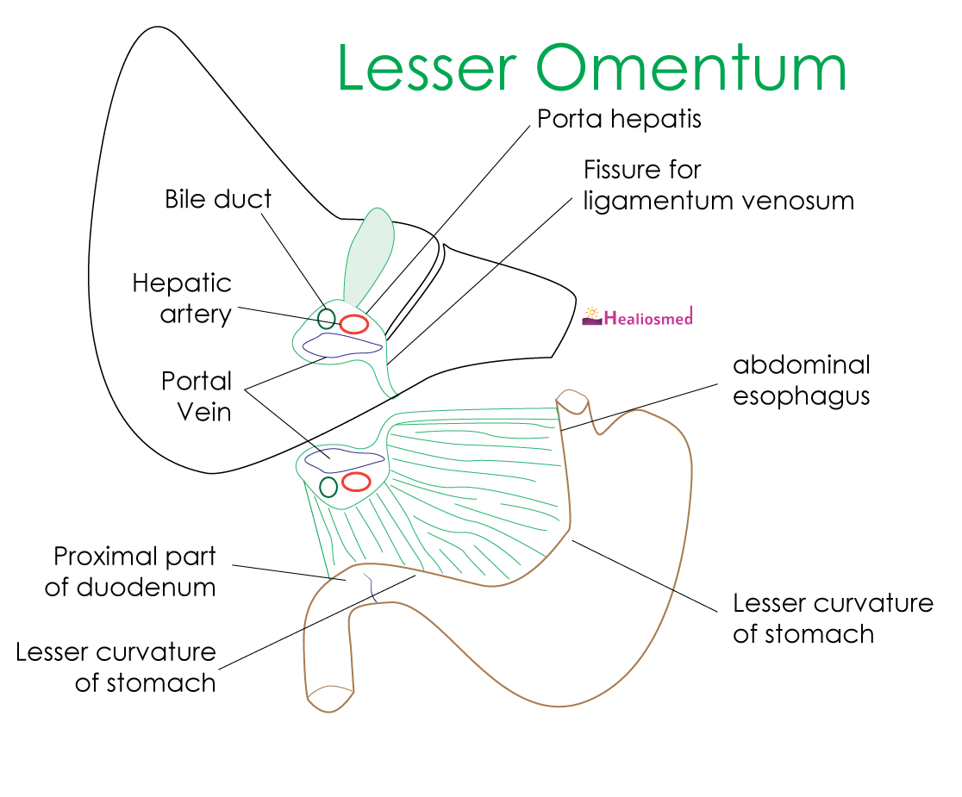
[YOUTUBE] https://youtu.be/OljjichkNN4

Contents of right free margin of lesser omentum are
- Portal vein (posteriorly)
- Hepatic duct
- Hepatic artery
- Lymphatics and autonomic nerves
___MCQ_START___
Lesser omentum is derived from
- Ventral mesogastrium between liver and stomach[CORRECT]
- Dorsal mesogastrium between stomach and spleen
- Ventral mesogastrium between stomach and spleen
- Dorsal mesogastrium between liver and stomach
____

The structure not related within the free margin of lesser omentum is
- Inferior vena cava[CORRECT]
- Portal vein
- Common bile duct
- Hepatic artery
____
____MCQ_END____

